CSE 581

**Lab 2: Basic Selects**

*Do this lab against the Northwind database.*

***For the entire lab, provide all of your SQL as text, inserted at the beginning of the document.***

***For each step also provide a screenshot of execution, showing the SQL and the results.***

***Please make sure both the SQL and the screenshots are marked w/ the question number that they are answering.***

**1.**

SELECT *

FROM [Order Details];

2.

SELECT *

FROM Customers

ORDER BY ContactName;

3.

SELECT *

FROM Orders

ORDER BY OrderDate ASC;

4.

SELECT *

FROM Orders

ORDER BY ShippedDate DESC;

5.

SELECT *

FROM Orders

WHERE ShippedDate is null;

6.

SELECT CompanyName, ContactName, ContactTitle

FROM Customers

WHERE CompanyName like 'D%';

7.

SELECT EmployeeID, FirstName, LastName

FROM Employees

WHERE LastName like 'D%' OR LastName like 'E%' OR LastName like 'F%';

8.

SELECT COUNT(SupplierID)

FROM Suppliers;

1.

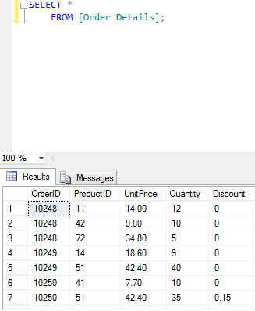

2. Select all data from the Customers table, ordered by **ContactName**.

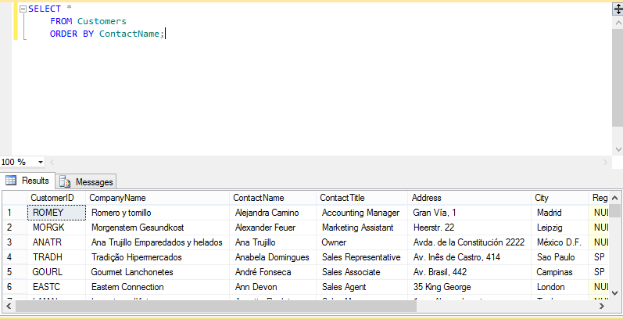

3. Select all data from the Orders table, ordered by OrderDate, oldest date on top.

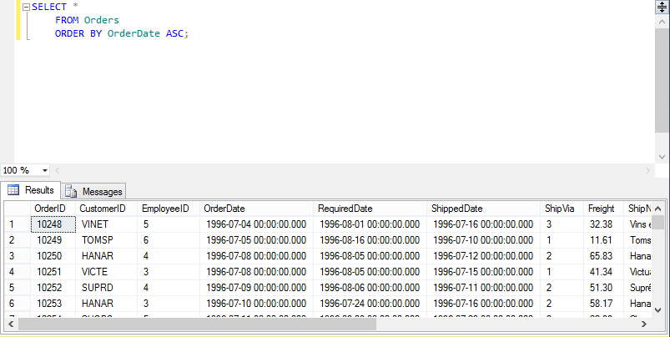

4. Select all data from the Orders table, ordered by ShippedDate, newest date on top.

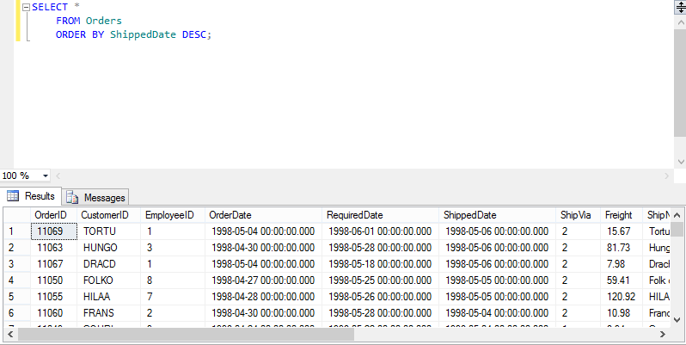

5. Select all data from the Orders table, where order has not shipped yet (ShippedDate is null).

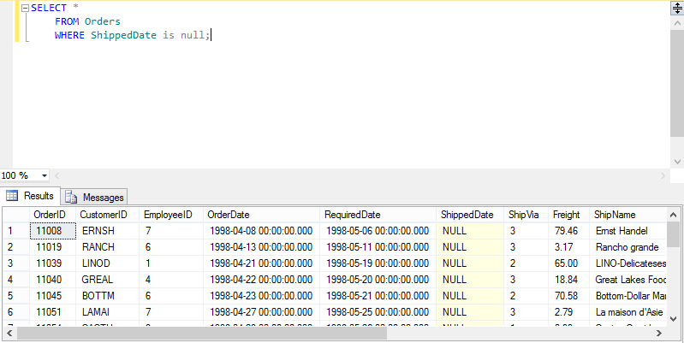

6. Select CompanyName, ContactName and ContactTitle from the Customers table, where Company Name starts with D.

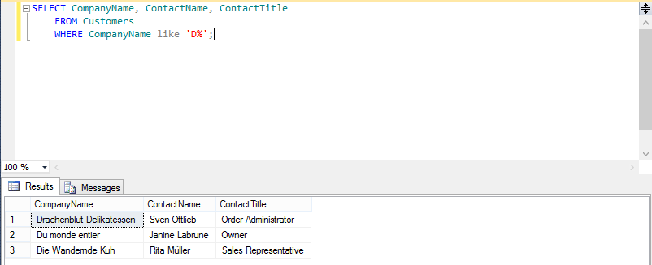

7. Select EmployeeID, FirstName, LastName and Title from the Employees table, where last name starts with D, E or F.

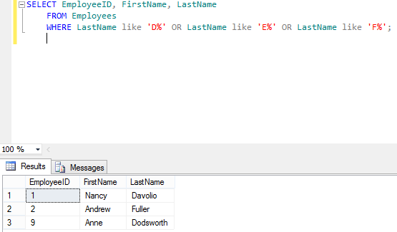

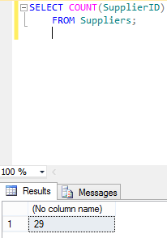8. Select number of records from the Suppliers table. *=> Result should be a single cell containing a single number (however many digits is appropriate).*